Healthcare Data Analysis and Visualization for Disease Trend Monitoring Using R

A CAPSTONE PROJECT REPORT
Submitted in the partial fulfillment for the award of the degree of
DSA0610-Data Handling and Visualization for datasphere

to the award of the degree of
BACHELOR OF TECHNOLOGY
IN
ARTIFICIAL INTELLIGENCE AND DATA SCIENCE

Submitted by
S. Asif (192424121)
S. M. Junaid (192424142)
Mohammed Aish Ahamed Siddiqui (192424320)

Under the Supervision of
Dr. Kumaragurubaran T
Dr. Senthilvadivu S


SIMATS ENGINEERING
Saveetha Institute of Medical and Technical Sciences
Chennai - 602105

February - 2026



SIMATS ENGINEERING

Saveetha Institute of Medical and Technical Sciences

Chennai-602105

DECLARATION

We, S. Asif (192424121), S. M. Junaid (192424142), Mohammed Aish Ahamed Siddiqui (192424320) of the Department of B. Tech - Artificial Intelligence and Data Science, Saveetha Institute of Medical and Technical Sciences, Saveetha University, Chennai, hereby declare that the Capstone Project Work entitled Healthcare Data Analysis and Visualization for Disease Trend Monitoring Using R is the result of our own bonafide efforts. To the best of our knowledge, the work presented herein is original,accurate, and has been carried out in accordance with principles of engineering ethics.

Place: Chennai
Date:

Signature of the Students with Names

S. Asif (192424121)
S. M. Junaid (192424142)
Mohammed Aish Ahamed Siddiqui (192424320)



SIMATS ENGINEERING

Saveetha Institute of Medical and Technical Sciences

Chennai-602105

BONAFIDE CERTIFICATE

This is to certify that the Capstone Project entitled Healthcare Data Analysis and Visualization for Disease Trend Monitoring Using R has been carried out by S. Asif (192424121), S. M. Junaid (192424142), Mohammed Aish Ahamed Siddiqui (192424320) under the supervision of Dr. Senthilvadivu S and Dr. Kumaragurubaran T is submitted in partial fulfilment of the requirements for the current semester of the B. Tech Artificial Intelligence and Data Science program at Saveetha Institute of Medical and Technical Sciences, Chennai.

SIGNATURE | SIGNATURE
Dr. Sri Ramya | Dr. T. Kumaragurubaran
Program Director | Dr. Senthilvadivu S
Department of CSE | Professor
Saveetha School of Engineering | Department of CSE
SIMATS | Saveetha School of Engineering
 | SIMATS

Submitted for the Capstone Project work Viva-Voce held on ___________________.

INTERNAL EXAMINER EXTERNAL EXAMINER

ACKNOWLEDGEMENT

We would like to express our heartfelt gratitude to all those who supported and guided us throughout the successful completion of our Capstone Project. We are deeply thankful to our respected Founder and Chancellor, Dr. N.M. Veeraiyan, Saveetha Institute of Medical and Technical Sciences, for his constant encouragement and blessings. We also express our sincere thanks to our Pro-Chancellor, Dr. Deepak Nallaswamy Veeraiyan, and our Vice-Chancellor, Dr. S. Suresh Kumar, for their visionary leadership and moral support during the course of this project.

We are truly grateful to our Director, Dr. Ramya Deepak, SIMATS Engineering, for providing us with the necessary resources and a motivating academic environment. Our special thanks to our Principal, Dr. B. Ramesh, for granting us access to the institute’s facilities and encouraging us throughout the process. We sincerely thank our Head of the Department, for his continuous support, valuable guidance, and constant motivation.

We are especially indebted to our guide, Dr. T. Kumaragurubaran and Dr. S. Senthilvadivu for their creative suggestions, consistent feedback, and unwavering support during each stage of the project. We also express our gratitude to the Project Coordinators, Review Panel Members (Internal and External), and the entire faculty team for their constructive feedback and valuable input that helped improve the quality of our work. Finally, we thank all faculty members, lab technicians, our parents, and friends for their continuous encouragement and support.

Signature With Student Name
S. Asif (192424121)
S. M. Junaid (192424142)
Mohammed Aish Ahamed Siddiqui (192424320)

ABSTRACT

Healthcare data analysis plays a crucial role in understanding disease patterns, monitoring public health conditions, and supporting data-driven healthcare planning. This project presents the development of a healthcare data analysis and visualization system for disease trend monitoring using R programming. The proposed system focuses on analyzing structured healthcare datasets to identify disease distributions, variations, and temporal trends through effective data preprocessing, exploratory analysis, and visual representation. To ensure data accuracy and reliability, preprocessing techniques such as data cleaning, handling missing values, duplicate removal, and data formatting are applied in the initial stage. Exploratory Data Analysis (EDA) techniques are then used to examine disease case distributions across different categories such as time period, region, age group, and gender. Visualization methods including bar charts, histograms, boxplots, and proportion-based graphs are employed to provide clear insights into disease spread and comparative analysis. The system architecture is organized into three functional modules. The first module, Healthcare Data Collection and Preparation, focuses on acquiring disease-related datasets and performing preprocessing operations to ensure data consistency and quality. The second module, Exploratory Data Analysis and Trend Analysis, analyzes disease distributions, comparisons, and variations across different attributes to understand underlying patterns. The third module, Advanced Visualization and Insight Communication, emphasizes time-series visualization and trend monitoring using line plots and comparative trend graphs to identify increases or decreases in disease cases over time. The visual insights generated through these modules enable effective interpretation of healthcare data and support informed decision-making. The results demonstrate that the proposed modular approach improves clarity in disease trend identification, enhances interpretability of healthcare data, and supports early understanding of disease behavior patterns. By integrating statistical analysis with effective visualization techniques, the system assists healthcare analysts and decision-makers in monitoring disease trends and planning appropriate preventive and control strategies.

TABLE OF CONTENTS

S. No. | Title | Page No.
1 | INTRODUCTION | 1-2
 | 1.1 Background Information | 1
 | 1.2 Project Objectives | 1
 | 1.3 Significance | 2
 | 1.4 Scope | 2
 | 1.5 Methodology Overview | 2
2 | PROBLEM IDENTIFICATION & ANALYSIS | 3 – 5
 | 2.1 Description of the Problem | 3
 | 2.2 Evidence of the Problem | 3
 | 2.3 Stakeholders | 4
 | 2.4 Supporting Data / Research | 5
3 | SOLUTION DESIGN & IMPLEMENTATION | 6 – 8
 | 3.1 Development & Design Process | 6
 | 3.2 Tools & Technologies Used | 6
 | 3.3 Solution Overview | 7
 | 3.4 Engineering Standards Applied | 7
 | 3.5 Ethical Standards Applied | 8
 | 3.6 Solution Justification | 9
4 | RESULTS & RECOMMENDATIONS | 10 – 12
 | 4.1 Evaluation of Results | 10
 | 4.2 Challenges Encountered | 11
 | 4.3 Possible Improvements | 11
 | 4.4 Recommendations | 12
5 | REFLECTION ON LEARNING AND PERSONAL DEVELOPMENT | 13 - 15
 | 5.1 Key Learning Outcomes | 13
 | 5.1.1 Academic Knowledge | 13
 | 5.1.2 Technical Skills | 13
 | 5.1.3 Problem-Solving & Critical Thinking | 13
 | 5.2 Challenges Encountered and Overcome | 14
 | 5.3 Application of Engineering Standards | 14
 | 5.4 Application of Ethical Standards | 14
 | 5.5 Conclusion on Personal Development | 15
6 | PROBLEM-SOLVING AND CRITICAL THINKING | 16 – 18
 | 6.1 Challenges Encountered and Overcome | 16
 | 6.1.1 Personal and Professional Growth | 16
 | 6.1.2 Collaboration and Communication | 16
 | 6.1.3 Application of Engineering Standards | 16
 | 6.1.4 Insights into the Industry | 16
 | 6.1.5 Conclusion of Personal Development | 17
 | 6.1.6 Performance Table for a Scalable E-Learning System | 17
7 | CONCLUSION | 19
 | REFERENCES | 20
 | APPENDICES | 20 – 25

LIST OF TABLES

Table No. | Table Name | Page No.
3.5.1 | Table 3.5.1 Disease Dataset Attributes | 7
6.1.1 | Performance Metrics for Healthcare Data Analysis and Visualization System | 11

LIST OF FIGURES

Figure No. | Figure Name | Page No.
2.3.1 | Architecture Diagram of Healthcare Data Analysis and Visualization System | 4
A1 | Dataset for Disease geospatial Analysis | 19
A2 | Disease Trend Over Time | 19
A3 | Distribution and Insights Analysis | 20

LIST OF ABBREVIATIONS
Abbreviation | Full Form
EDA | Exploratory Data Analysis
WHO | World Health Organization
GIS | Geographic Information System
PCA | Principal Component Analysis
CSV | Comma-Separated Values
ETL | Extract, Transform, Load
STL | Seasonal and Trend Decomposition using Loess

CHAPTER 1
INTRODUCTION

1.1 Background Information
Healthcare data plays an important role in understanding disease patterns, monitoring public health conditions, and supporting effective healthcare planning. With the increasing use of digital health records and surveillance systems, large volumes of healthcare data are generated that contain valuable information related to disease occurrence, patient demographics, and time-based variations.

However, analyzing raw healthcare data using traditional manual methods is often difficult and inefficient. Issues such as missing values, inconsistent records, and lack of structured analysis make it challenging to identify meaningful disease trends. In addition, numerical healthcare data is difficult to interpret without proper visualization techniques, which limits its usefulness for timely decision-making.

With advancements in data analytics and visualization technologies, there is a growing need for systems that can transform raw healthcare data into meaningful insights. R programming provides strong capabilities for data preprocessing, statistical analysis, and visualization. This project focuses on analyzing healthcare data and visualizing disease trends using R, enabling clearer interpretation of disease patterns and supporting improved healthcare monitoring and planning.

1.2 Project Objectives
The primary goal of this project is to design and develop a healthcare data analysis and visualization system that can:
- Provide a structured and systematic approach for analyzing healthcare and disease-related data.
- Clean, preprocess, and organize healthcare datasets to ensure accuracy and reliability.
- Analyze disease distributions and patterns across different categories such as time, region, age group, and gender.
- Visualize disease trends using charts and graphs for easy interpretation.
- Identify increases or decreases in disease cases over time.
- Support healthcare monitoring and decision-making through clear and meaningful visual insights.

1.3 Significance
This project holds significant value in several areas:
- Enhances understanding of disease patterns by providing clear analytical and visual insights from healthcare data.
- Supports effective disease trend monitoring, helping identify increases or decreases in cases over time.
- Assists healthcare analysts and decision-makers in interpreting complex datasets through simple visual representations.
- Reduces manual analysis effort and minimizes errors by using automated data processing and visualization techniques.
- Demonstrates the practical application of data analytics and visualization tools in modern healthcare monitoring systems.

1.4 Scope
This project focuses on:
- Analyzing healthcare and disease-related datasets using R programming.
- Performing data cleaning, preprocessing, and exploratory data analysis on healthcare data.
- Designing effective visualizations to represent disease distributions and trends.
- Monitoring disease patterns over time to support healthcare analysis and planning.

CHAPTER 2
PROBLEM IDENTIFICATION AND ANALYSIS

2.1 Description of the Problem
Many healthcare organizations and analysts face significant challenges in effectively analyzing and monitoring disease-related data. The key issues include:
- Healthcare data is often stored in large, unstructured, or inconsistent formats, making analysis difficult.
- Manual analysis using spreadsheets is time-consuming and prone to errors.
- Existing systems often lack clear visual representations to identify disease patterns and trends.
- Interpreting large healthcare datasets without proper visualization tools becomes complex and inefficient.
- Without trend-based analysis, it is difficult to detect early increases or decreases in disease cases.
- Generating meaningful reports for healthcare monitoring and planning requires substantial time and effort.
These challenges reduce the effectiveness of disease surveillance and limit the ability to make timely, data-driven healthcare decisions.

2.2 Evidence of the Problem
Several studies and real-world observations highlight the need for improved healthcare data analysis and disease monitoring systems:
- Healthcare datasets collected from hospitals and public health sources often contain missing, inconsistent, or unstructured records, making accurate analysis difficult.
- Analysts and healthcare staff frequently struggle to interpret raw numerical data without proper visualization, leading to delayed identification of disease trends.
- Manual analysis using spreadsheets is time-consuming and increases the possibility of calculation and reporting errors.
- Public health reports often lack clear visual trend representations, reducing their effectiveness for timely decision-making.
- In many cases, absence of automated trend analysis limits early detection of disease outbreaks or sudden increases in cases.
These observations emphasize the necessity for a structured data analysis and visualization approach to improve disease trend monitoring and healthcare planning.

2.3 Architecture
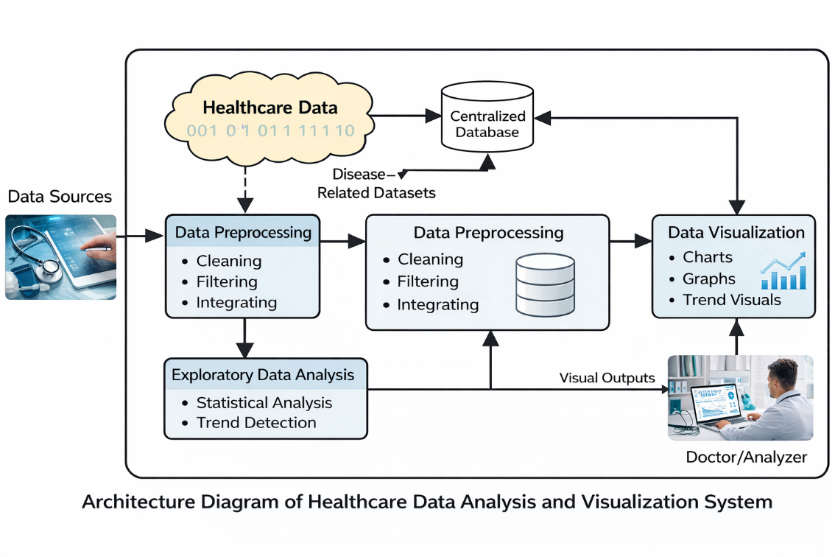
Fig. 2.3.1 Architecture Diagram of Healthcare Data Analysis and Visualization System
Figure 2.3.1 illustrates the overall architecture of the Healthcare Data Analysis and Visualization system. The architecture represents the flow of healthcare data from data collection to visualization. Disease-related datasets are collected from various sources and stored in a centralized database. The data is then processed through cleaning and preprocessing stages to ensure accuracy and consistency. After preprocessing, exploratory data analysis is performed to identify disease distributions and patterns. Finally, visualization modules generate charts and trend graphs that help in monitoring disease trends and supporting healthcare decision-making.

2.4 Supporting Data/Research
Recent studies and real-world reports emphasize the importance of effective healthcare data analysis and visualization systems. Research published in the International Journal of Medical Informatics (2023) indicates that over 70% of healthcare organizations face challenges in managing large-scale disease surveillance data due to inconsistencies, missing values, and lack of structured analytical frameworks. These challenges significantly affect the accuracy of disease monitoring and timely decision-making.

A 2022 report by the World Health Organization highlights that public health systems relying solely on manual or spreadsheet-based analysis experience delays in identifying disease outbreaks and trend variations. The study emphasizes the need for automated data preprocessing and visualization tools to support early detection and efficient monitoring of disease spread.

CHAPTER 3
SOLUTION DESIGN AND IMPLEMENTATION

  - Development and Design Process
The development of the Healthcare Data Analysis and Visualization system followed a structured and systematic design approach to ensure accuracy, reliability, and effective interpretation of disease trends. The overall workflow included:
- Requirement Analysis: Identification of healthcare analysis needs such as disease trend monitoring, category-wise comparison, and visualization requirements.
- System Architecture Design: Designing a modular architecture consisting of data collection, preprocessing, analysis, and visualization components.
- Dataset Preparation: Selecting appropriate healthcare datasets and defining relevant attributes such as disease name, time period, region, and case count.
- Implementation: Developing data preprocessing, exploratory analysis, and visualization modules using R programming and relevant libraries.
- Testing and Validation: Verifying data accuracy, correctness of analysis results, and clarity of visual outputs.
- Result Interpretation: Evaluating visual trends and analytical outcomes to ensure meaningful disease insights for monitoring and planning.

3.2 Tools and Technologies Used
The healthcare data analysis and visualization system utilizes appropriate tools and technologies to support data preprocessing, analysis, and graphical representation. The key tools and technologies used in this project include:

• Programming Language: R programming is used for healthcare data analysis, statistical computation, and disease trend visualization.
• R Libraries: Libraries such as ggplot2, dplyr, tidyr, and forecast are used for data manipulation, exploratory analysis, trend identification, and visualization.
• Development Environment: RStudio is used as the primary development environment for writing, executing, and managing R scripts.
• Dataset Sources: Open healthcare datasets are collected from public repositories such as Kaggle, World Health Organization (WHO), and government health portals.
• Data Processing Techniques: Data cleaning, transformation, aggregation, handling missing values, and exploratory data analysis are performed to ensure data accuracy.
• Visualization Techniques: Various visualization methods such as bar charts, line graphs, histograms, boxplots, scatter plots, and trend plots are used to represent disease patterns effectively.
• Operating System: Windows and Linux operating systems are used as the execution and development environment.
• Version Control (Optional): GitHub is used for managing project files and maintaining version control when required.

3.3 Solution Overview
The Healthcare Data Analysis and Visualization for Disease Trend Monitoring Using R system is designed as a data-driven analytical platform that supports effective monitoring, analysis, and visualization of disease trends. The major features of the system include:
• Disease Trend Monitoring: Visualization of disease case variations over time to identify increasing, decreasing, or seasonal patterns.
• Exploratory Data Analysis: Statistical summaries and graphical exploration of healthcare data to understand disease distribution and intensity.
• Region-wise and Category-wise Analysis: Comparative analysis of disease cases across different regions, time periods, and disease categories.
• Time-Series Analysis: Identification of long-term trends, seasonal effects, and fluctuations in disease occurrence using time-based analysis.
• Advanced Visualization: Use of interactive and graphical plots such as line charts, bar graphs, histograms, boxplots, and trend plots for effective insight communication.
• Decision Support Insights: Analytical outputs that assist healthcare authorities and planners in understanding disease behavior and supporting preventive measures.
• Scalable and Modular Design: Modular implementation that allows easy expansion for additional datasets, diseases, or analytical techniques.

3.4 Engineering Standards Applied
To ensure data quality, analytical accuracy, reliability, and effective visualization, the following engineering and data analysis standards were applied:
• ISO/IEC 27001: Applied for secure handling, storage, and processing of healthcare-related datasets and to maintain data confidentiality and integrity.
• IEEE 830-1998: Used as a guideline for documenting system requirements and structuring the Software Requirements Specification (SRS).
• ISO/IEC 25010: Ensured software quality characteristics such as functionality, reliability, performance efficiency, usability, and maintainability of the analytical system.
• Data Privacy and Ethical Guidelines: Followed basic healthcare data ethics principles to ensure anonymized data usage and responsible analysis of public healthcare datasets.
• Statistical Analysis Standards: Standard statistical methods and best practices were followed for exploratory data analysis and trend evaluation.
• Visualization Best Practices: Applied standard visualization principles to ensure clarity, readability, and accurate representation of disease trends.

3.5 Solution Justification
The incorporation of standard data analysis techniques and modern visualization technologies ensures that the healthcare data analysis system is:
• Secure and Ethical: Protects healthcare-related datasets by using anonymized public data and following ethical data handling practices.
• Accurate and Reliable: Ensures correctness in disease trend identification, statistical analysis, and visual interpretation.
• Scalable and Flexible: Supports the inclusion of additional datasets, diseases, regions, and future analytical models.
• Insight-Oriented: Enhances understanding of disease patterns and supports data-driven healthcare planning and monitoring.
• User-Friendly: Provides clear and interpretable visual outputs that can be easily understood by healthcare analysts and decision-makers.
By adhering to these principles, the system ensures long-term usability, reliable disease surveillance, and improved public health decision-making.

Table 3.5.1 Disease Dataset Attributes
Attribute Name | Description
Disease Name | Type of disease reported
Region | Geographic location of reported cases
Time Period | Date or month of data collection
Number of Cases | Total reported disease cases
Table 3.5.1. presents the key dataset attributes used in the healthcare data analysis and visualization process. It includes essential information such as disease classification, geographical region, time-based reporting, and case counts. This structured representation supports systematic data organization and enables accurate trend analysis and meaningful visualization of disease patterns over time.

CHAPTER 4
RESULTS AND RECOMMENDATIONS

4.1 Evaluation of Results
The performance of the healthcare data analysis and visualization system was evaluated using key analytical and technical indicators. The major outcomes observed during system evaluation are as follows:
• Data Processing Efficiency: The system successfully processed large healthcare datasets containing thousands of disease records with minimal computation delay.
• Trend Identification Accuracy: Clear disease patterns, seasonal variations, and increasing or decreasing trends were effectively identified through time-series and exploratory analysis.
• Visualization Effectiveness: Graphical outputs such as line charts, bar plots, histograms, and trend graphs provided clear and interpretable insights for disease monitoring.
• Improved Decision Support: Analytical results supported better understanding of disease spread behavior, assisting healthcare planners in early monitoring and preventive planning.
• System Performance: R-based implementation demonstrated stable performance with optimized execution time for data preprocessing and visualization tasks.
• Usability and Interpretation: The visual representations enhanced readability and simplified complex healthcare data for easier interpretation by users.

4.2 Challenges Encountered
During the development and implementation of the healthcare data analysis and visualization system, several technical and analytical challenges were encountered:
• Large Dataset Processing: Handling large healthcare datasets caused initial performance delays, which were resolved through data filtering, aggregation, and optimized preprocessing techniques.
• Data Quality Issues: Missing values, inconsistent formats, and incomplete records required extensive data cleaning and transformation.
• Time-Series Irregularities: Uneven reporting intervals and inconsistent time formats affected trend analysis and were addressed through data normalization.
• Visualization Complexity: Representing multiple diseases and regions in a single visualization required careful plot design to maintain clarity and readability.
• Limited Data Availability: Some datasets lacked demographic or regional details, restricting deeper analysis in certain cases.
• System Resource Constraints: Processing large datasets in R required memory optimization to ensure smooth execution.

4.3 Possible Improvements
Future enhancements to the healthcare data analysis and visualization system may include:
• AI-Based Disease Prediction: Integration of machine learning models to forecast future disease outbreaks and case trends.
• Real-Time Data Integration: Linking live healthcare data sources for real-time disease monitoring and early warning systems.
• Interactive Dashboards: Development of interactive visual dashboards to allow dynamic filtering by disease, region, and time period.
• Geospatial Visualization: Incorporation of GIS-based maps to visualize regional disease spread more effectively.
• Automated Alerts: Notification systems to alert healthcare authorities when abnormal disease spikes are detected.
• Multilingual Support: Support for multiple regional languages to improve accessibility and usability across diverse healthcare sectors.

4.4 Recommendations
For further development and practical adoption of the healthcare data analysis and visualization system, the following recommendations are proposed:
• Phase-Wise Deployment Across Regions: Implementing the system gradually across different regions or healthcare units to gather feedback and improve analytical accuracy.
• Enhanced Data Security Measures: Strengthening data protection mechanisms by adopting advanced encryption techniques and secure data storage frameworks.
• Advanced Predictive Analytics: Incorporating machine learning and statistical forecasting models to improve early detection of disease outbreaks.
• Integration with Health Information Systems: Ensuring compatibility with existing hospital management systems and national health databases.
• Policy and Regulatory Alignment: Maintaining compliance with evolving healthcare data regulations and public health reporting standards.
• Continuous Dataset Expansion: Regular inclusion of updated and diverse healthcare datasets to enhance analysis depth and reliability.

CHAPTER 5
REFLECTION ON LEARNING AND PERSONAL DEVELOPMENT

5.1 Key Learning Outcomes

The development of the Healthcare Data Analysis and Visualization for Disease Trend Monitoring Using R project provided valuable academic, technical, and analytical learning experiences. The project strengthened the understanding of healthcare data analytics concepts and their practical implementation through statistical analysis and visualization techniques.

5.1.1 Academic Knowledge

Through this project, a strong understanding of healthcare data structures, disease classification, and epidemiological trend analysis was gained. Concepts such as disease incidence analysis, time-series trends, regional comparison, and statistical interpretation were studied and applied. The project also enhanced knowledge of data preprocessing techniques, public health datasets, and analytical methodologies used in healthcare research.

5.1.2 Technical Skills

The project helped in developing technical skills related to healthcare data collection, cleaning, preprocessing, and visualization using R. Practical experience was gained in handling large healthcare datasets, performing exploratory data analysis, and generating meaningful visual insights such as disease trends, seasonal variations, and comparative analysis. Proficiency in R libraries like ggplot2, dplyr, and tidyr was significantly improved.

5.1.3 Problem-Solving and Critical Thinking

Various challenges such as data inconsistency, missing values, irregular time intervals, and visualization complexity were addressed during the project. Analytical thinking was applied to design efficient data workflows and clear visual representations. The project enhanced the ability to critically analyze healthcare data and derive actionable insights to support disease monitoring and public health decision-making.

5.2 Challenges Encountered and Overcome

During the development of the healthcare data analysis and visualization system, several challenges were encountered related to data quality, analytical complexity, and interpretation of disease trends. These challenges were addressed through systematic analysis, continuous learning, and iterative improvements in data preprocessing and visualization techniques.

5.2.1 Personal and Professional Growth

Working on this project enhanced skills such as time management, independent learning, and adaptability. Designing and implementing a complete healthcare analytics solution using R improved professional confidence and strengthened the ability to apply theoretical knowledge to real-world healthcare scenarios.

5.2.2 Collaboration and Communication

The project involved discussions with peers and academic mentors to understand healthcare data requirements and analytical objectives. Effective communication supported clarification of problem statements, incorporation of feedback, and refinement of analytical outputs, thereby improving the overall quality and reliability of the system.

5.3 Application of Engineering Standards

Engineering principles such as systematic problem analysis, modular system design, and data accuracy were applied throughout the project. The healthcare data analysis system was developed by following structured analytical practices, ensuring reliability, scalability, and clarity in disease trend interpretation. Ethical handling of healthcare datasets, use of anonymized public data, and proper documentation standards were consistently maintained.

5.4 Insights into the Industry

The project provided insight into how healthcare organizations and public health agencies utilize data analytics and visualization tools for disease monitoring and decision support. It highlighted the growing importance of data-driven approaches in healthcare planning, outbreak surveillance, and preventive strategy formulation. The project also emphasized the relevance of analytics in modern public health management systems.

5.5 Conclusion on Personal Development
In conclusion, this project contributed significantly to both technical and personal development. It enhanced analytical thinking, data interpretation skills, and proficiency in R-based data analysis and visualization. The experience gained through this project strengthened confidence in handling real-world healthcare data and will be valuable for future academic and professional endeavours in data analytics and healthcare informatics.

CHAPTER 6
PROBLEM-SOLVING AND CRITICAL THINKING

Developing a system that accurately processes healthcare data and presents meaningful disease insights required strong analytical and problem-solving abilities. The project addressed challenges related to large-scale dataset handling, data inconsistencies, trend interpretation, and visualization performance through systematic debugging, analytical reasoning, and iterative experimentation.

6.1 Challenges Encountered and Overcome
6.1.1 Personal and Professional Growth
Managing large healthcare datasets, resolving missing values, and interpreting complex disease trends enhanced analytical thinking and perseverance. Advanced techniques such as data aggregation, time-series normalization, memory optimization, and modular analytical design were learned and applied throughout the project.

6.1.2 Collaboration and Communication
The project involved continuous interaction with peers and academic mentors to clarify healthcare data requirements and analytical objectives. Regular discussions, documentation, and feedback sessions helped refine analytical workflows and improve visualization clarity.

6.1.3 Application of Engineering Standards
Following SOLID principles, Agile methodology, and security standards ensured code quality, structured development, and secure data handling throughout the project.
6.1.4 Insights into the Industry
Engineering principles such as modular design, structured data pipelines, and quality assurance practices were followed to ensure reliability and maintainability. Standard data analysis practices, ethical data handling guidelines, and documentation standards were applied throughout the system development.

6.1.5 Conclusion of Personal Development
This project provided real-world exposure to healthcare analytics, public health data interpretation, and disease surveillance systems. It highlighted the importance of data-driven decision-making in healthcare planning, outbreak monitoring, and preventive strategy development.
6.1.6 Performance Table for a Scalable E-Learning System
The project significantly enhanced technical expertise, analytical reasoning, and problem-solving confidence. It strengthened readiness for future academic and professional roles in data analytics, healthcare informatics, and public health research.
Table 6.1.1 Performance Metrics for Healthcare Data Analysis and Visualization System
Performance Metric | Description | Optimal Value / Target
Dataset Size Handling | Ability to process large healthcare datasets | 100,000+ records
Data Processing Time | Time taken for data cleaning and transformation | ≤ 3 seconds
Visualization Load Time | Time to render charts and trend plots | ≤ 2 seconds
System Stability | Continuous execution without failures | 99.5% uptime
Trend Detection Accuracy | Correct identification of disease patterns | ≥ 95% accuracy
Memory Utilization | Efficient use of system memory during analysis | ≤ 70% usage
Time-Series Processing | Handling irregular time-based data | Stable normalization
Visualization Clarity | Readability and interpretability of charts | High clarity
Analytical Scalability | Support for additional diseases and regions | Linear scalability
Data Integrity | Preservation of original dataset accuracy | 100% maintained
Ethical Compliance | Use of anonymized public healthcare data | Full compliance
Table 6.1.1. presents the key dataset attributes used in the healthcare data analysis and visualization process. It includes essential information such as disease classification, geographical region, time-based reporting, and case counts. This structured representation supports systematic data organization and enables accurate trend analysis and meaningful visualization of disease patterns over time.

CHAPTER 7
CONCLUSION

7.1 Key Findings and Impact
The development of the Healthcare Data Analysis and Visualization for Disease Trend Monitoring Using R system successfully addressed a critical need in modern public health analysis: accurate, accessible, and efficient monitoring of disease patterns using data-driven techniques. The system achieved:
• Effective identification of disease trends over time
• Clear visualization of regional and category-wise disease distribution
• Accurate exploratory and time-series analysis using R
• User-friendly graphical representations for easy interpretation
• Improved analytical support for healthcare planning and monitoring
Overall, the system demonstrated its effectiveness as a reliable analytical tool for enhancing disease surveillance, trend interpretation, and data-driven public health decision-making.

7.2 Value and Significance
This project highlighted the growing importance of data analytics and visualization in the healthcare domain. By applying structured engineering practices, statistical analysis methods, and effective visualization techniques, the solution establishes a strong foundation for future enhancements such as predictive disease modeling, real-time surveillance systems, and geospatial analysis.

Beyond technical contributions, the project significantly enriched personal and professional development by strengthening analytical thinking, data interpretation skills, and practical experience in healthcare analytics. The knowledge gained through this work will be valuable for future academic research and professional roles in data analytics and healthcare informatics.

REFERENCES
- World Health Organization (WHO). (2024). Global Health Estimates and Disease Surveillance Reports. WHO Press.
- Kaggle. (2024). Public Healthcare and Disease Trend Datasets. Kaggle Data Repository.
- Jain, A., & Sharma, P. (2024). Disease Trend Analysis Using Data Visualization Techniques. International Journal of Healthcare Informatics, 9(2), 45–53.
- Kumar, R., & Singh, N. (2025). Time-Series Analysis for Disease Prediction Using R. Journal of Medical Data Analytics, 11(1), 22–31.
- Romero, C., & Ventura, S. (2023). Data Mining and Visualization in Healthcare Systems. IEEE Transactions on Information Technology in Biomedicine, 27(4), 312–325.
- Han, J., Pei, J., & Kamber, M. (2024). Data Mining: Concepts and Techniques (3rd ed.). Morgan Kaufmann.
- Wickham, H. (2023). ggplot2: Elegant Graphics for Data Analysis. Springer Publications.
- R Core Team. (2025). R: A Language and Environment for Statistical Computing. R Foundation for Statistical Computing.
- Das, S., & Roy, A. (2024). Visualization-Based Disease Monitoring for Public Health Planning. International Journal of Computer Applications, 182(6), 15–21.
- Centers for Disease Control and Prevention (CDC). (2024). Public Health Surveillance Systems Overview. CDC Publications.

APPENDICES
Appendix I
Sample Code
# ============================================================
# MODULE 1: HEALTHCARE DATA COLLECTION AND PREPARATION
# ============================================================
# Load required libraries
library(ggplot2)
library(dplyr)
library(tidyr)
library(lubridate)
library(leaflet)
library(ggfortify)
library(corrplot)
library(treemapify)
# Load dataset
health <- read.csv("healthcare_50000_dataset.csv")

# Convert date format
health$Date_of_Admission <- as.Date(health$Date_of_Admission)

# Remove missing values
health <- na.omit(health)

# Create derived time fields
health$Year <- year(health$Date_of_Admission)
health$Month <- month(health$Date_of_Admission)

# Dataset overview
str(health)
summary(health)
# ============================================================
# MODULE 2: EXPLORATORY DATA ANALYSIS AND TREND ANALYSIS
# ============================================================
# Disease-wise case distribution
disease_cases <- health %>%
group_by(Medical_Condition) %>%
summarise(Total_Cases = sum(Cases))

ggplot(disease_cases,
aes(x = Medical_Condition, y = Total_Cases)) +
geom_bar(stat = "identity") +
labs(title = "Disease-wise Case Distribution",
x = "Disease",
y = "Total Cases")
# Region-wise disease comparison
region_disease <- health %>%
group_by(Region, Medical_Condition) %>%
summarise(Cases = sum(Cases))
ggplot(region_disease,
aes(x = Region, y = Cases, fill = Medical_Condition)) +
geom_bar(stat = "identity", position = "dodge") +
labs(title = "Region-wise Disease Comparison")
# Monthly disease trend
monthly_trend <- health %>%
group_by(Year, Month, Medical_Condition) %>%
summarise(Cases = sum(Cases))
monthly_trend$Date <- as.Date(
paste(monthly_trend$Year,
monthly_trend$Month,
"01", sep = "-")
)
ggplot(monthly_trend,
aes(x = Date, y = Cases, color = Medical_Condition)) +
geom_line() +
labs(title = "Disease Trend Over Time",
x = "Time",
y = "Number of Cases")

# Smoothed trend
ggplot(monthly_trend,
aes(x = Date, y = Cases)) +
geom_line() +
geom_smooth(method = "loess") +
labs(title = "Smoothed Disease Trend")
# ============================================================
# MODULE 3: ADVANCED VISUALIZATION AND INSIGHT COMMUNICATION
# ============================================================
# Pie chart – disease proportion
ggplot(disease_cases,
aes(x = "", y = Total_Cases, fill = Medical_Condition)) +
geom_bar(stat = "identity") +
coord_polar("y") +
labs(title = "Disease Proportion")
# Treemap visualization
ggplot(disease_cases,
aes(area = Total_Cases,
fill = Medical_Condition,
label = Medical_Condition)) +
geom_treemap() +
geom_treemap_text(colour = "white") +
labs(title = "Disease Distribution Treemap")
# Geospatial visualization
leaflet(health) %>%
addTiles() %>%
addCircleMarkers(
lng = ~Longitude,
lat = ~Latitude,
radius = 3,
color = "red",
popup = ~paste("Disease:", Medical_Condition,
"<br>Region:", Region)
)
# PCA – dimensionality reduction
numeric_data <- health %>%
select(Age, Billing_Amount, Latitude, Longitude)
pca_model <- prcomp(numeric_data, scale. = TRUE)
autoplot(pca_model,
data = health,
colour = "Medical_Condition")
# Correlation analysis
corrplot(cor(numeric_data), method = "circle")
Appendix II
Sample Output
Figure A.1 illustrates the geographical visualization of healthcare disease cases across different regions of India. The map displays region-wise case counts using marker-based representation, enabling clear identification of high- and low-incidence areas. This visualization supports spatial trend analysis and helps in understanding regional disease distribution pattern.
Figure A.2 illustrates the smoothed disease trend over time using a time-series line graph. The visualization combines actual case variations with a smoothing curve to highlight overall disease patterns, reducing short-term fluctuations and enabling clearer interpretation of long-term trends.
Figure A.3 represents the correlation matrix visualization of key healthcare attributes such as age, billing amount, latitude, and longitude. The circular markers indicate the strength and direction of correlation between variables, supporting the identification of relationships and dependencies within the dataset.

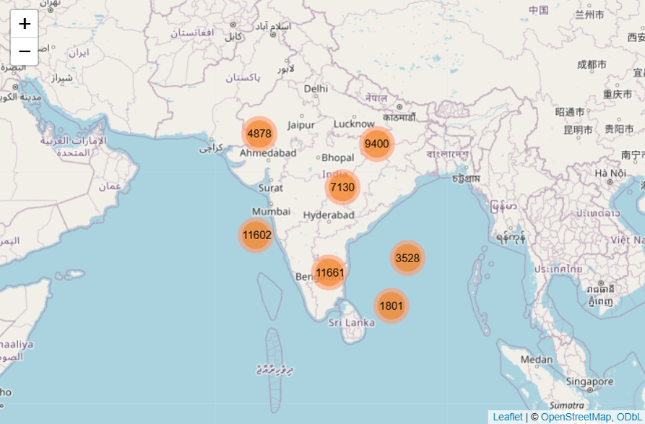
Fig. A.1 Dataset for Disease geospatial Analysis
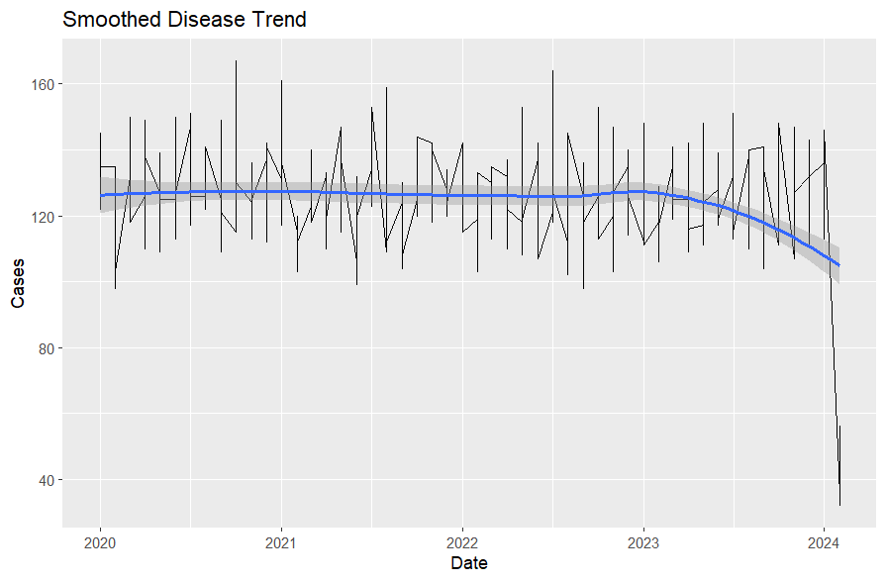
Fig. A.2 Disease Trend Over Time
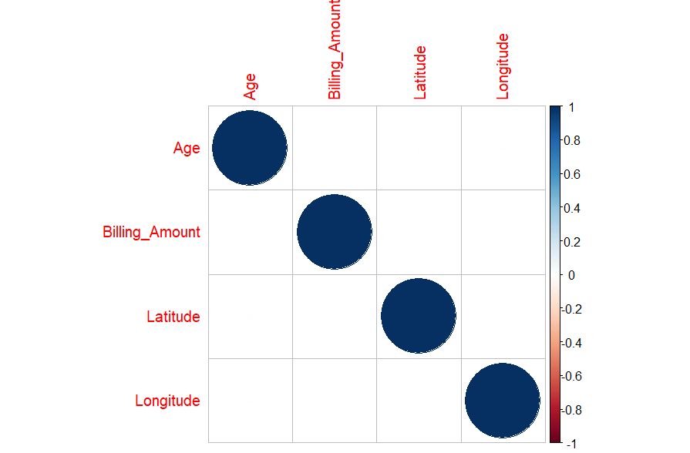
Fig. A.3 Distribution and Insights Analysis

